PNT2022TMID02998

# IBM – NALAIYA THIRAN PROJECT

**SMART FASHION RECOMMENDER**

**APPLICATION**

**INDUSTRY MENTOR : KRISHNA CHAITANYA**

**FACULTY MENTOR : DR.NISHA**

|  |  |  |
| --- | --- | --- |
| **TEAM ID** | **:** | PNT2022TMID02998 |
| **TEAM LEAD** | **:** | SANJAY S |
| **TEAM MEMBER** | **:** | SAKTHIVEL C R |
| **TEAM MEMBER** | **:** | SREEJITH.D |
| **TEAM MEMBER** | **:** | IRFAN ALI S |

## ABSTRACT

Fashion is perceived as a meaningful way of self-expressing that people use for different purposes. It seems to be an integral part of every person in modern societies, from everyday life to exceptional events and occasions. Fashionable products are highly demanded, and consequently, fashion is perceived as a desirable and profitable industry. Although this massive demand for fashion products provides an excellent opportunity for companies to invest in fashion-related sectors, it also faces different challenges in answering their customer needs.

In recent years, the textile and fashion industries have witnessed an enormous amount of growth in fast fashion. On e-commerce platforms, where numerous choices are available, an efficient recommendation system is required to sort, order, and efficiently convey relevant product content or information to users. Smart Fashion Recommender Application have attracted a huge amount of attention from fast fashion retailers as they provide a personalized shopping experience to consumers. Smart Fashion Recommender Application have been introduced to address these needs.

## TABLE OF CONTENT

|  |  |  |
| --- | --- | --- |
| **CHAPTER** | **CONTENTS** | **PAGE NO** |
| **1** | **INTRODUCTION**  1.1 PROJECT OVERVIEW  1.2 PURPOSE | **05** |
| **2** | **LITERATURE SURVEY**  2.1 EXISTING PROBLEM  2.2 REFERENCES  2.3 PROBLEM STATEMENT DEFINITION | **06** |
| **3** | **IDEATION & PROPOSED SOLUTION**  3.1 EMPATHY MAP CANVAS  3.2 IDEATION & BRAINSTROMING  3.3 PROPOSED SOLUTION  3.4 PROBLEM SOLUTION FIT | **10** |
| **4** | **REQUIREMENT ANALYSIS**  4.1 FUNCTIONAL REQUIREMENT  4.2 NON-FUNCTIONAL REQUIREMENTS | **16** |
| **5** | **PROJECT DESIGN**  5.1 DATA FLOW DIAGRAMS  5.2 SOLUTION & TECHNICAL  ARCHITECTURE  5.3 USER STORIES | **18** |
| **6** | **PROJECT PLANNING & SCHEDULING**  6.1 SPRINT PLANNING & ESTIMATION  6.2 SPRINT DELIVERY SCHEDULE  6.3 REPORTS FROM JIRA | **24** |

|  |  |  |
| --- | --- | --- |
| **7** | **CODING & SOLUTIONING**  7.1 FEATURE 1  7.2 FEATURE 2  7.3 DATABASE SCHEMA | **28** |
| **8** | **TESTING**  8.1 TEST CASES  8.2 USER ACCEPTANCE TESTING | **70** |
| **9** | **RESULTS**  9.1 PERFORMANCE METRICS | **71** |
| **10** | **ADVANTAGES & DISADVANTAGES** | **73** |
|  |  | **74** |
| **11** | **CONCLUSION** |  |
| **12** | **FUTURE SCOPE** | **75** |
| **13** | **APPENDIX**  SOURCE CODE  GITHUB & PROJECT DEMO LINK | **76** |

1. **INTRODUCTION** 
   1. **PROJECT OVERVIEW**

The Fashion industry is one of the larger industries around the world. One of the things that has remained constant throughout human civilization is humans covering their bodies with a piece of cloth. Initially, this cloth was worn as protection from the harsh climates of those ages. Later on, as we humans learned to fend for ourselves from the unforgiving climates, the cloth started to serve a different purpose. Fashion these days showcases the individuality of the person. There are many things that can be said about a person based on their fashion sense.

* 1. **PURPOSE**

There is currently no existing system that is capable of recommending clothes based on the occasion. Different occasions call for different clothing. Moreover, a lot of fashion is based on the color combinations of outfits. A person with no or little fashion sense will have a hard time to decide on clothes that leave a lasting impression. The proposed Fashion Recommendation System is intended to be used by individual users in order to store images of the clothes that they own in what is called a digital wardrobe and also to get recommendations by the system on what clothes to wear for a given occasion. The main aim of the project is to recommend the most appropriate clothes for a given occasion based on the clothes existing in the user’s wardrobe to relieve the user of the burden of making decisions about what clothing to wear. Such a system should be capable of helping someone who has no fashion sense to wear clothes that leave a good impression on others. The system should be such that it is easily accessible and easy to take advantage of the various features that it provides. One of the features should be the ability to store images that the user uploads into a wardrobe. A wardrobe is a very useful entity that the user can use to view and manage the images of clothes that they have uploaded. This feature can also be used by the recommendation algorithm to recommend the clothes. Another feature is the classification of the type and color of the clothing that is uploaded by the user. The system should be capable of handling the 4 basic clothing types: Shirt, T-Shirt, Pants and Shoes.

## 2. LITERATURE SURVEY

**2.1 EXISTING PROBLEM:**

In existing system only simple web application and their rating has been implemented in existing system, An ecommerce product recommendation engine is a piece of technology that displays recommended products to shoppers throughout your store. It uses machine learning to get smarter and show increasingly relevant products to shoppers based on their interests and previous browsing behavior

In existing model is content based filtering scheme has been employed in existing model **The content-based filtering method** analyzes customer data on the likes and dislikes of each user (cookies allow tracking over multiple visits), then makes recommendations based on the browsing history of that user. The idea behind content-based filtering is that if you enjoy a certain item, you’ll likely also enjoy a similar item. An example of a contentbased filtering system would be if you were listening to Pandora and consistently ‘liked’ downtempo jazz music.

**The collaborative-filtering method** incorporates data from users who have purchased similar products, then combines that information to make decisions about recommendations. The advantage to this filtering method is that it is capable of making complex recommendations on items such as music or movies without having to

‘understand’ what the item is. This method of filtering operates under the assumption that users will prefer recommendations that are based on purchases they made in the past. Here’s an example: If customer A likes a specific line of products that customer B also likes (assuming they have similar interests), then collaborate-filtering would assume that customer A would like other products that customer B purchased and vice versa.

**A hybrid method** combines the content-based and collaborative-based methods to incorporate group decisions but focuses the output based on the attributes of a specific visitor. An example of a hybrid filtering system would be how Spotify curates its personalized ‘Discover Weekly’ playlists. If you’ve ever listened to a personalized Spotify playlist, it’s shocking how accurately they’re able to recommend songs based on what you like. The secret behind how they pull this off is through a complex hybrid filtering system that aggregates data on your listening habits as well as similar users’ listening habits, to create a playlist of unique songs that align with your personal taste.

**2.2 REFERENCES:**

1. Liu, C., & Wu, X. (2016). Large-scale recommender system with compact latent factor model, 64, 467 475.doi:10.1016/j.eswa.2016.08.009.

1. Adomavicius, G., & Tuzhilin, A. (2005). Toward the next generation of recommender systems: A survey of the state-of-the-art and possible extensions.

IEEE Transactions on Knowledge and Data Engineering, 17(6), 734–749. doi:10.1109/TKDE.2005.99.

1. Zhang, Y.; Caverlee, J. Instagrammers, Fashionistas, and Me: Recurrent Fashion Recommendation with Implicit Visual Influence. In Proceedings of the

28th ACM International Conference on Information and Knowledge Management, Beijing, China, 3–7 November 2019; pp. 1583–1592. [Google Scholar] [CrossRef][Green Version].

1. JH (Janghyun), Baek; John, Tsai; Justin, Shamoun; Muriel, Marable; Ying

Cui,Ying;(2020) Amazon Recommender System. 5. Qingqing Tu,Le Dong -An Intelligent Personalized Fashion Recommendation System -2010 6. batuhan aşiroğlu- smart clothing recommendation system with deep learning 2019 3rd International Symposium on MultidisciplinaryYew Cheong Hou and K. S. M.

Sahari, "Identifying corners of clothes using image processing method," (2010) In

International Conference on Intelligent and Advanced

* 1. Systems, Manila, 2010, pp. 1-5.

1. M. Yang and K. Yu, "Real-time clothing recognition in surveillance videos," (2011) In 18th IEEE International Conference on Image Processing, Brussels, 2011, pp. 2937-

2940.

1. Y. Wen, X. Liu and B. Xu, "Personalized Clothing Recommendation Based on Knowledge Graph,"(2018) 2018 International Conference on Audio, Language and Image Processing (ICALIP), Shanghai, pp. 1-5.
2. O'Connell, L. (n.d.). Topic: Apparel Market Worldwide. Retrieved August 30, 2020, from https://www.statista.com/topics/5091/apparel- market-worldwide/
3. Zhang, Yan & Liu, Xiang & Shi, Yunyu & Guo, Yunqi & Xu, Chaoqun & Zhang,

Erwen & Tang, Jiaxun & Fang, Zhijun. (2017). Fashion Evaluation Method for

* 1. Clothing Recommendation Based on Weak Appearance Feature. Scientific

Programming. 2017. 1-12. 10.1155/2017/8093057.

### 2.3 PROBLEM STATEMENT DEFINITION

The personal information collected by recommenders raises the risk of unwanted exposure of that information. Also, malicious users can bias or sabotage the recommendations that are provided to other users.In recent years, the textile and fashion industries have witnessed an enormous amount of growth in fast fashion. On e-commerce platforms, where numerous choices are available, an efficient recommendation system is required to sort, order, and efficiently convey relevant product content or information to users.

* The problem of the work is to design static web applications deployments with customer deployment
* Lack of interaction between application and user
* User need to navigate across multiple pages to choose right product
* Confusion in choosing product
* Lack of sales
* Complex User Interface.
* Lack of proper guidance.

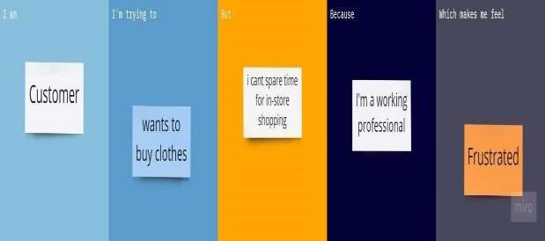

## 3.IDEATION & PROPOSED SOLUTION

We have come up with a new innovative solution through which you can directly do your online shopping based on your choice without any search. It can be done by using the chatbot.

In this project you will be working on two modules :

1. Admin and
2. User

**ADMIN:**

The role of the admin is to check out the database about the stock and have a track of all the things that the users are purchasing.

**USER :**

The user will login into the website and go through the products available on the website. Instead of navigating to several screens for booking products online, the user can directly talk to Chatbot regarding the products. Get the recommendations based on information provided by the user.

***FEATURES OF CHATBOT :***

* + - Using chatbot we can manage user's choices and orders.
    - The chatbot can give recommendations to the users based on their interests.
    - It can promote the best deals and offers on that day.
    - It will store the customer's details and orders in the database.
    - The chatbot will send a notification to customers if the order is confirmed.
    - Chatbots can also help in collecting customer feedback.

* 1. **EMPATHY MAP CANVAS:**

An empathy map is a simple, easy-to-digest visual that captures knowledge about a user’s behaviours and attitudes. It is a useful tool to helps teams better understand their users. Creating an effective solution requires understanding the true problem and the person who is experiencing it. The exercise of creating the map helps participants consider things from the user’s perspective along with his or her goals and challenges. An empathy map is a collaborative tool teams can use to gain a deeper insight into their customers.

* 1. **IDEATION & BRAINSTROMING:**

A group problem-solving technique that involves the spontaneous contribution of ideas from all members of the group.

The mulling over of ideas by one or more individuals in an attempt to devise or find a solution to a problem.

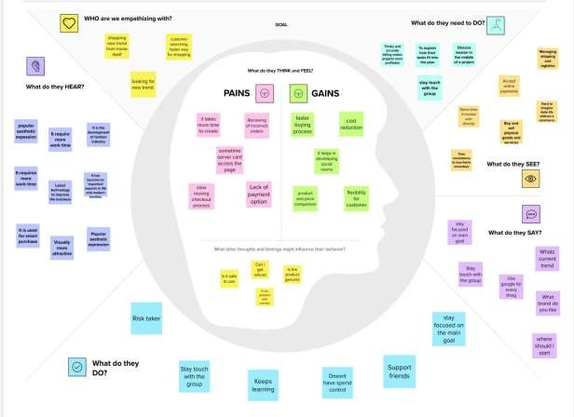

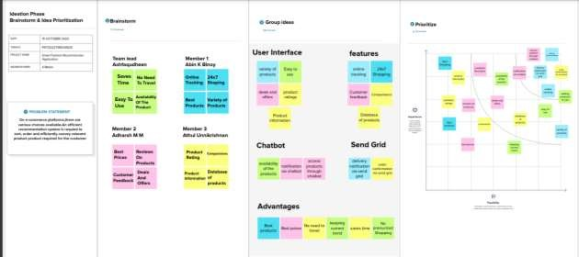

**3.3 PROPOSED SOLUTION:**

SMART FASHION RECOMMENDER APPLICATION

Project team shall fill the following information in proposed solution template.

|  |  |  |
| --- | --- | --- |
| **S.No.** | **Parameter** | **Description** |
| • | Problem Statement (Problem to be solved) | Customer can use the app to browse the products and add them to their shopping cart. The bot will assist users in receiving product recommendation. |
| • | Idea / Solution description | We have come up with a new innovative solution through which you can directly do your online shopping based on your choice without any search. It can be done by using the chatbot. |
| • | Novelty / Uniqueness | Share design inspirations to chatbot.  Utilize user's 3D model to find an outfit. |
| • | Social Impact / Customer Satisfaction | Instead of navigating to several screens for booking products online, the user can directly talk to Chatbot regarding the products. We can visualize ourselves as a 3D model, for the better understanding of how the product suits us. |
| • | Business Model (Revenue Model) | While getting a big order from a major retailer might sound like a good thing for a fledgling brand, it means the brand has a short time to somehow produce that inventory and hire the necessary employees without any money upfront. |
| • | Scalability of the Solution | Technological developments such as color changes and the integration of conductive sensors etc. Could revolutionize the way designers think about fashion. |

**3.3 PROBLEM SOLUTION FIT**

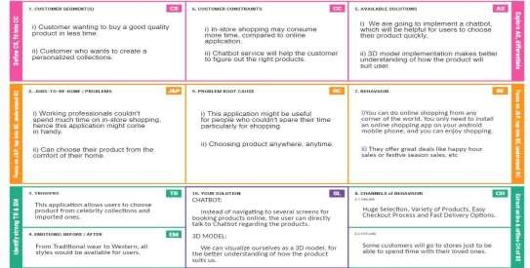

## 4.REQUIREMENT ANALYSIS

**4.1 FUNCTIONAL REQUIREMENT:**

|  |  |  |
| --- | --- | --- |
| **FR No.** | **Functional Requirement (Epic)** | **Sub Requirement (Story / Sub-Task)** |
| FR-1 | User Registration | Registration through Form  Registration through Gmail  Registration through mobile number  Registration through LinkedIN |
| FR-2 | User Confirmation | Confirmation via Email  Confirmation via OTP |
| FR-3 | Advanced Search Capabilities | sorting and filtering options |
| FR-4 | Checking item availability | item availability in specific locations |
| FR-5 | Shopping cart | My cart button  Add-to-cart button  Remove-from-cart button |
| FR-6 | Super-fast checkout | Online transfer, credit card payment,  paying with mobile wallets |
| FR-7 | Checking the shipping status | Option to easily check the shipping status of items ordered in the store |

**SMART FASHION RECOMMENDER APPLICATION**

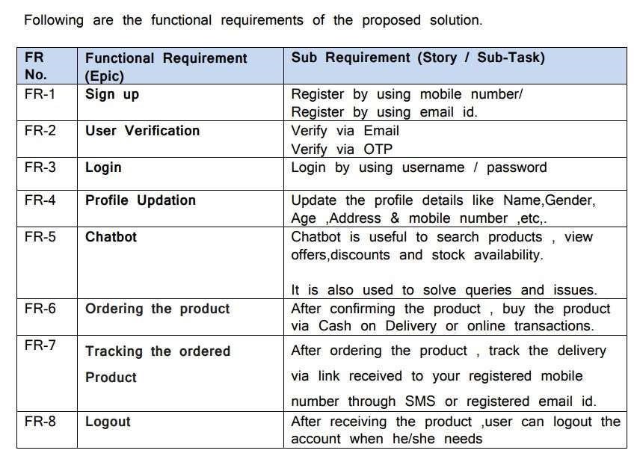

**4.2 NON-FUNCTIONAL REQUIREMENTS:**

**SMART FASHION RECOMMENDER APPLICATION**

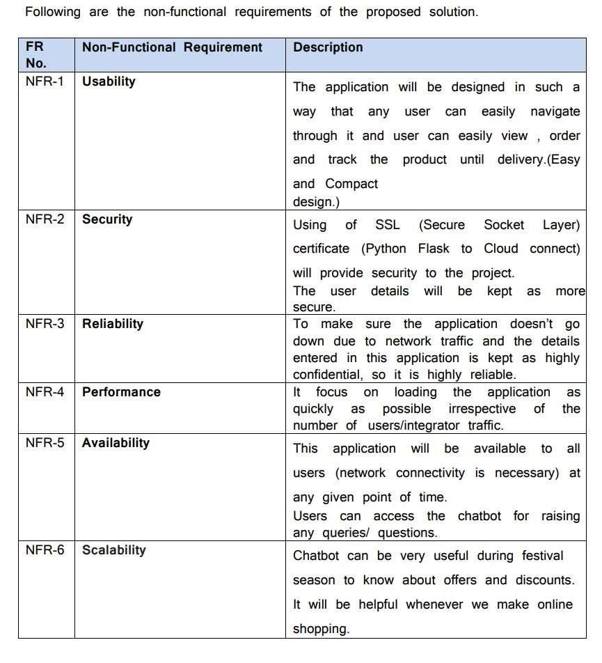

**5.PROJECT DESIGN**

**5.1 DATA FLOW DIAGRAMS:**

A Data Flow Diagram (DFD) is a traditional visual representation of the information flows within a system. A neat and clear DFD can depict the right amount of the system requirement graphically. It shows how data enters and leaves the system, what changes the information, and where data is stored.

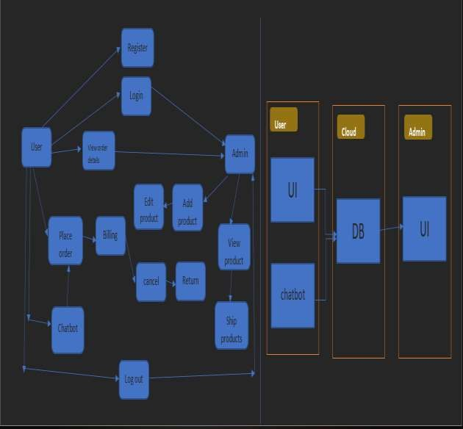

**5.2 SOLUTION & TECHNICAL ARCHITECTURE:**

We have developed a new innovative solution through which you can directly do your online shopping based on your choice without any search. It can be done by using the chatbot. In this project you will be working on two modules:

* Admin
* User

Instead of searching for products in the search bar and navigating to individual products to find required preferences, this project leverages the use of chatbots to gather all required preferences and recommend products to the user. The solution is implemented in such a way as to improve the interactivity between customers and applications. The chatbot sends messages periodically to notify offers and preferences. For security concerns, this application uses a token to authenticate and authorize users securely. The token has encoded user id and role. Based on the encoded information, access to the resources is restricted to specific users.

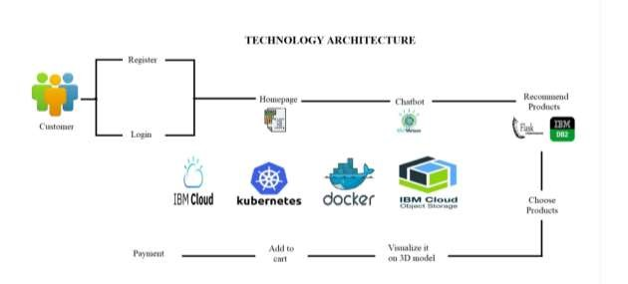

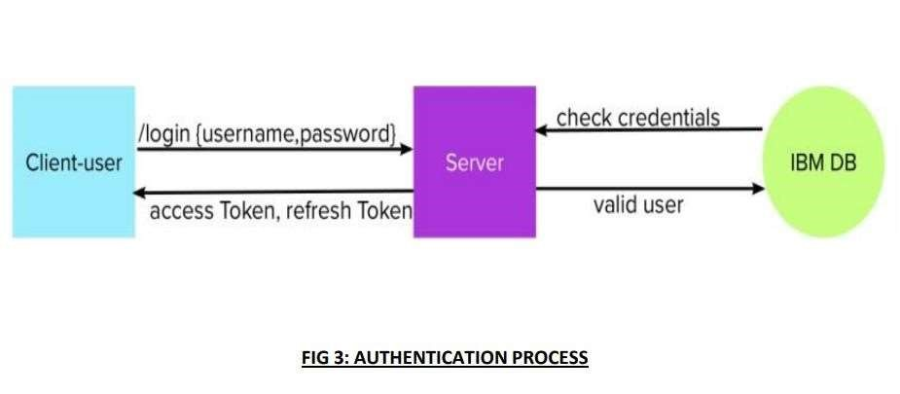

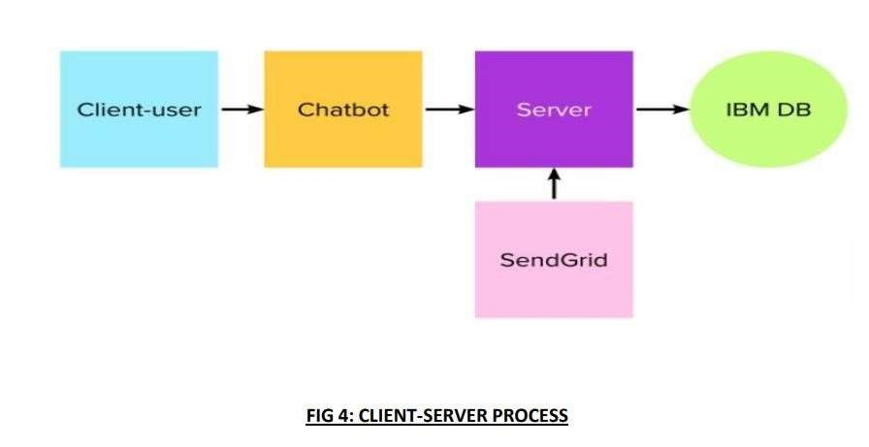

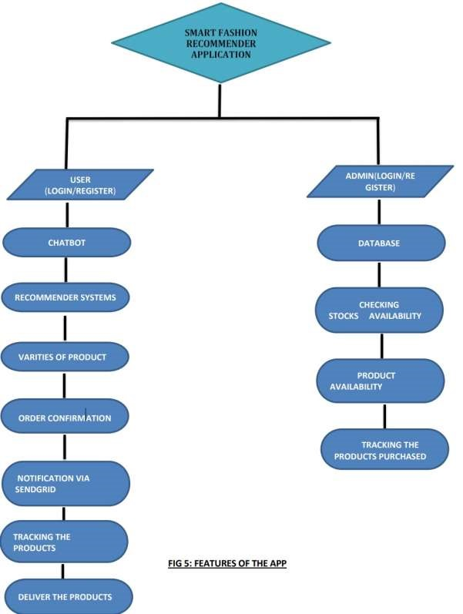

**5.3 USER STORIES :**

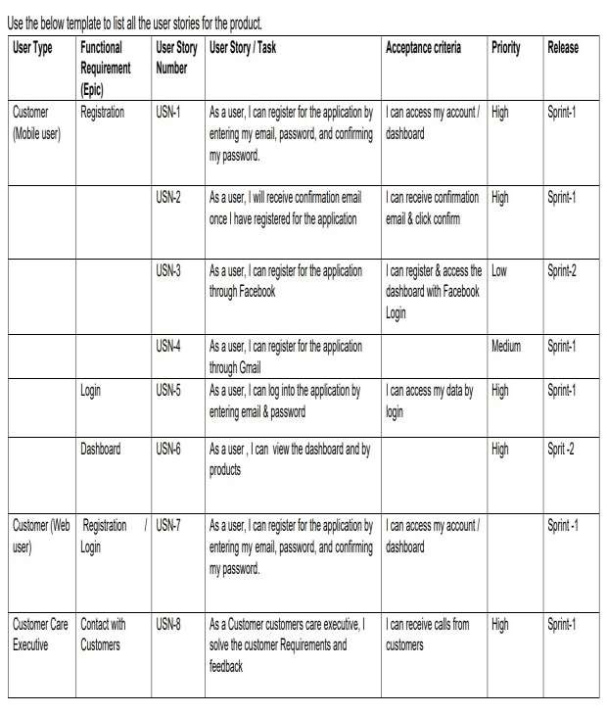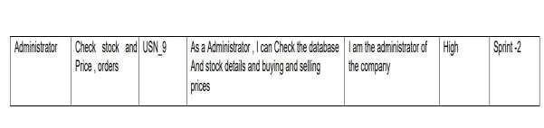

**6. PROJECT PLANNING & SCHEDULE**

* 1. **SPRINT PLANNING & ESTIMATION:**

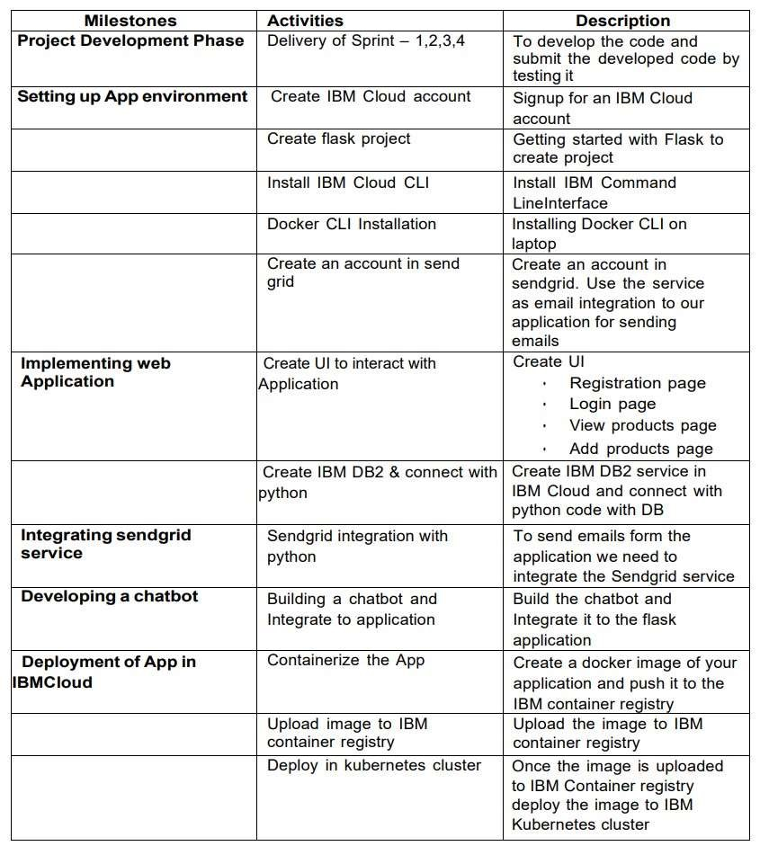

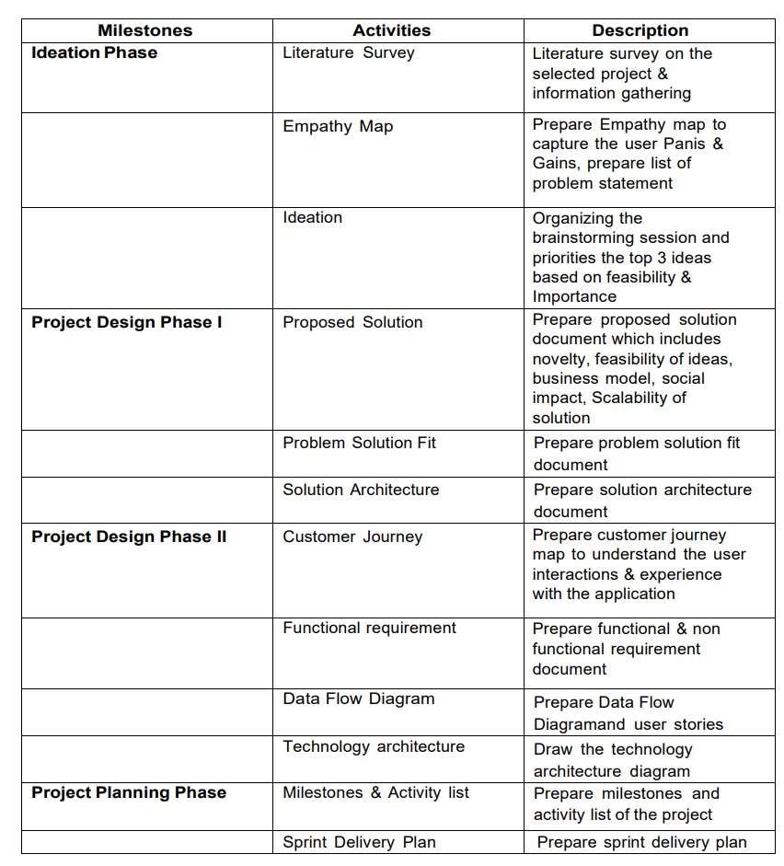

* 1. **SPRINT DELIVERY SCHEDULE:**

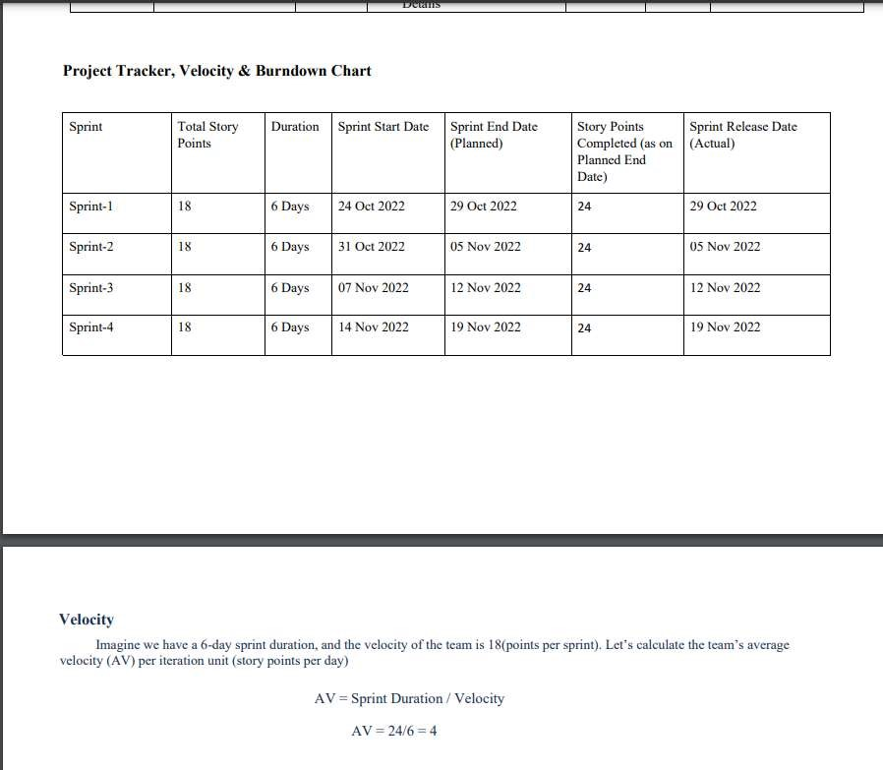

* 1. **EPORTS FROM JIRA:**

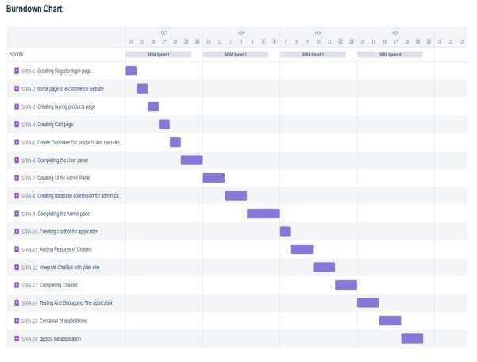

**7. CODING & SOLUTIONING**   **7.1 FEATURE-1:**

**HOMEPAGE.HTML:**

|  |
| --- |
| <style> body { background: #2a2e32;  }    .text-small { font-size: 0.9rem;  } a { color: inherit; text-decoration: none; transition: all 0.3s;  } a:hover, a:focus { text-decoration: none;  }    .form-control { background: #212529; border-color: #545454;  }    .form-control:focus { background: #212529;  } footer { background: #212529;  }    /*=============    ==================*/  /* ==========================================  Rating stars |

|  |
| --- |
| PNT2022TMID02807        ========================================== */  .checked { color: orange;  }  </style>      <div style="background-color: rgba(0, 11, 86, 0.874);">  <marquee direction="left" style="color: white;font-size: larger;backgroundcolor: black;">Deals & special offer upto  20% wekend special sales upto 40% (Fashion sale for all products 50% offer shop now) </marquee>    <nav class="navbar navbar-expand-lg navbar-light bg-light" style="paddingbottom: 20px;padding-left: 150px;">  <a class="navbar-brand" href="{% url 'home'%}" style="margin-left:  500px;font-weight: 900;">  <img src="{% static 'image/smart.png'%}" width="250" height="200" alt="">  <p style="font-family: 'Times New Roman', Times, serif;"><i class="fa fa-map-marker" aria-hidden="true"> Smart  Fashion, 44, Townhall Road, Coimbatore-641039</i></p>  </a>  <br>    <button class="navbar-toggler" type="button" data-toggle="collapse" datatarget="#navbarNavAltMarkup"  aria-controls="navbarNavAltMarkup" aria-expanded="false" arialabel="Toggle navigation">  <span class="navbar-toggler-icon"></span>  </button>    </nav>  <nav class="navbar navbar-expand-lg navbar-light bg-light">  <div class="collapse navbar-collapse" id="navbarNavAltMarkup"  style="background-color: rgba(8, 7, 7, 0.923);padding-top: 20px;paddingbottom: 20px;border-radius: 20px;">  <br>  <div class="navbar-nav">        33 |

<a href="{% url 'home'%}"><button class="btn btn-outline-success"

|  |
| --- |
| style="color: white;margin-left: 100px;font-size: larger;borderradius: 20px;">Home</button></a>  <a href="{% url 'about'%}"><button class="btn btn-outline-success" style="margin-left: 00px;color: white;margin-left: 80px;font-size:  larger;border-radius: 20px;">About Online  Smart  Fashion </button></a>    <a href="{% url 'login'%}"><button class="btn btn-outline-success" data-toggle="modal" data-target="#exampleModalLong" style="margin-left: 80px;color: white;font-size: larger;borderradius: 20px;">Pucharse  Collection</button></a>  </div>    <a href="{% url 'admin'%}"><button class="btn btn-outline-success" style="margin-left: 00px;color: white;margin-left: 100px;font-size:  larger;border-radius: 20px;">Admin  Login</button></a>      <button class="btn btn-outline-success" style="margin-left: 00px;color: white;margin-left: 100px;font-size:  larger;border-radius: 10px;"data-toggle="modal" data-  target="#exampleModalCenter" style="margin-left: 1200px;">Ask Any  Help??</button>    <a href="{% url 'getintouch'%}">  <button class="btn btn-outline-success" style="margin-left: 00px;color: white;margin-left: 100px;font-size:  larger;border-radius: 20px;">Get In  Touch</button></a>  </div>  <br>  </nav>  <br>    <!---------->  <div id="carouselExampleFade" style="color: rgba(0, 0, 0, 0.567);padding-top: 5px;" |

class="carousel slide carousel-fade" data-bs-ride="carousel">

|  |
| --- |
| <div class="carousel-inner">  <div class="carousel-item active">  <img src="{% static 'image/shirt.jpg'%}" style="width: 300px; height:  500px" class="d-block w-100" alt="...">  </div>  <div class="carousel-item">  <img style="width: 100px; height: 500px;" src="{% static  'image/shirts.jpeg'%}" class="d-block w-100" alt="...">  </div>    <div class="carousel-item">  <img style="width: 300px; height: 500px;" src="{% static  'image/sares.jpg'%}" class="d-block w-100" at="...">  </div>    </div>  <button class="carousel-control-prev" style="background-color: black;" type="button" data-bs-target="#carouselExampleFade" data-bs-slide="prev">  <span class="carousel-control-prev-icon" aria-hidden="true"></span> |

**REGISTER.HTML:**

|  |
| --- |
| style> body {  background: #2a2e32;  }    .text-small {  font-size: 0.9rem;  } a { color: inherit; text-decoration: none; transition: all 0.3s; |

}

|  |
| --- |
| a:hover, a:focus { text-decoration: none;  }    .form-control { background: #ffffff; border-color: #545454;  }    .form-control:focus { background: #ffffff;  } footer { background: #212529;  }    /*=============    ==================*/  /* ==========================================  Rating stars  ========================================== */  .checked {  color: orange;  }  </style>    <marquee direction="left" style="color: white;font-size: larger;backgroundcolor: black;">Deals & special offer upto  20% wekend special sales upto 40% (Fashion sale for all products 50% offer shop now) </marquee>    <nav class="navbar navbar-expand-lg navbar-light bg-light" style="paddingbottom: 20px;padding-left: 150px;">  <a class="navbar-brand" href="{% url 'home'%}" style="margin-left:  500px;font-weight: 900;">  <img src="{% static 'image/smart.png'%}" width="250" height="200" alt=""> |

<p style="font-family: 'Times New Roman', Times, serif;"><i class="fa

|  |
| --- |
| fa-map-marker" aria-hidden="true"> Smart  Fashion, 44, Townhall Road, Coimbatore-641039</i></p> </a> |

* 1. **FEATURE 2:**

**LOGIN.HTML:**

|  |
| --- |
| <style> body { background: #2a2e32;  }    .text-small {  font-size: 0.9rem;  } a { color: inherit; text-decoration: none; transition: all 0.3s;  } a:hover, a:focus { text-decoration: none;  }    .form-control { background: #ffffff; border-color: #000000;  }    .form-control:focus { background: #f3f4f6;  } footer { background: #212529; |

|  |
| --- |
| }    /*=============    ==================*/  /* ==========================================  Rating stars  ========================================== */  .checked {  color: orange;  }  </style> |

**CHATBOT (SOURCE CODE) :**

|  |
| --- |
| function talk(){ var know = {  "Hi" : "Hello ",  "What say about your smart fashion?" : "This shopping hall is 2011 is start in smart fashion shopping and all vertical dress available.",  "What about your dress collection?" : "Court and shirts, Sarees, Jean  Pants, Kid's Dress, ect...",  "How to Purchasing?" : "Your see the top navbar, click on purchase button then you have purchasing dresses.",  "Your followers" : "I have my family of 5000 members, i don't have follower ,have supportive Famiy ", "ok" : "Thank You So Much ",  "Bye" : "Okay! Will meet soon.."  };  var user = document.getElementById('userBox').value; document.getElementById('chatLog').innerHTML = user + "<br>"; if (user in know) {  document.getElementById('chatLog').innerHTML = know[user] + "<br>";  }else{ document.getElementById('chatLog').innerHTML = "Sorry,I didn't understand  <br>";  }  } |

* 1. **DATABASE SCHEMA:**

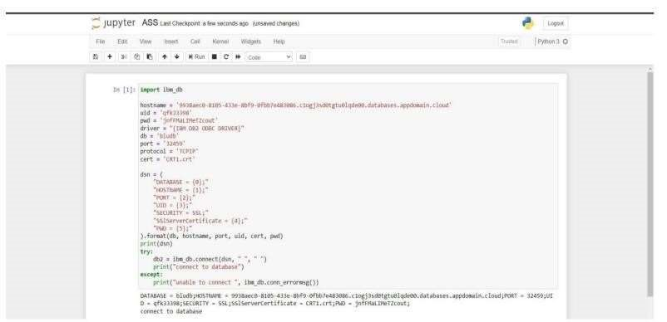

## 8. TESTING

**8.1 TEST CASES:**

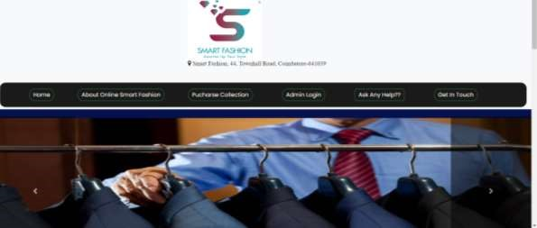

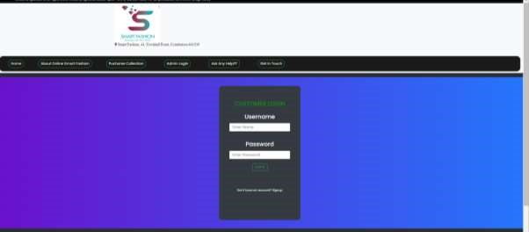

**9.RESULTS**

9.1 PERFORMANCE METRICS:

The performance of a recommendation algorithm is evaluated by using some specific metrics that indicate the accuracy of the system. The type of metric used depends on the type of filtering technique. Root Mean Square Error (RMSE), Receiver Operating Characteristics (ROC), Area Under Cover (AUC), Precision, Recall and F1 score is generally used to evaluate the performance or accuracy of the recommendation algorithms.

***Root-mean square error (RMSE)***. RMSE is widely used in evaluating and comparing the performance of a recommendation system model compared to other models. A lower RMSE value indicates higher performance by the recommendation model. RMSE, as mentioned by [[61],](https://encyclopedia.pub/entry/13081#ref_61) can be as represented as follows:

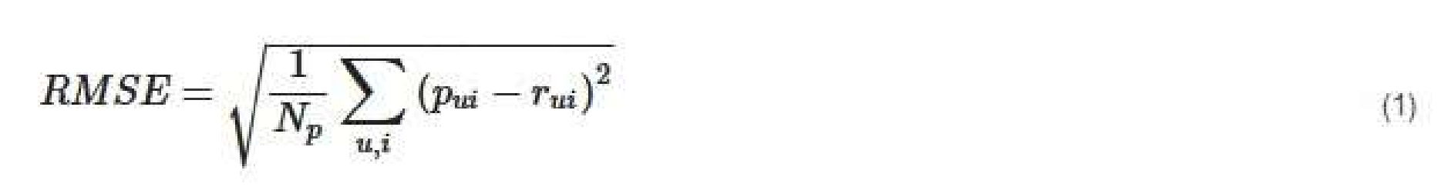 where, *Np* is the total number of predictions, *pui* is the predicted rating that a user *u* will select an item *i* and *rui* is the real rating.

***Precision***. Precision can be defined as the fraction of correct recommendations or predictions (known as True Positive) to the total number of recommendations provided, which can be as represented as follows:

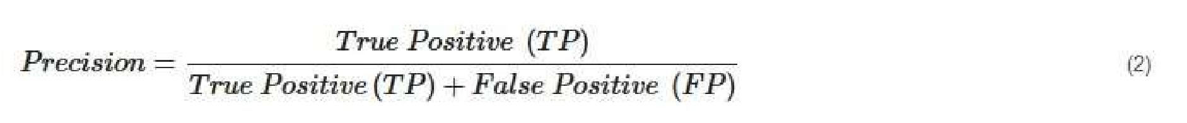

It is also defined as the ratio of the number of relevant recommended items to the number of recommended items expressed as percentages.

***Recall***. Recall can be defined as the fraction of correct recommendations or predictions (known as True Positive) to the total number of correct relevant recommendations provided, which can be as represented as follows:



It is also defined as the ratio of the number of relevant recommended items to the total number of relevant items expressed as percentages.

***F1 Score***. F1 score is an indicator of the accuracy of the model and ranges from 0 to 1, where a value close to 1 represents higher recommendation or prediction accuracy. It represents precision and recall as a single metric and can be as represented as follows:

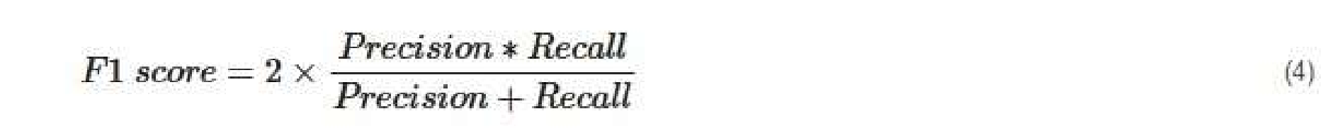

***Coverage***. Coverage is used to measure the percentage of items which are recommended by the algorithm among all of the items.

***Accuracy***. Accuracy can be defined as the ratio of the number of total correct recommendations to the total recommendations provided, which can be as represented as follows:



***Intersection over union (IoU)***. It represents the accuracy of an object detector used on a specific dataset [[62].](https://encyclopedia.pub/entry/13081#ref_62)



***ROC***. ROC curve is used to conduct a comprehensive assessment of the algorithm’s performance [[57].](https://encyclopedia.pub/entry/13081#ref_57)

***AUC***. AUC measures the performance of recommendation and its baselines as well as the quality of the ranking based on pairwise comparisons [[5].](https://encyclopedia.pub/entry/13081#ref_5)

*Rank aware top-N metrics*. The rank aware top-N recommendation metric finds some of the interesting and unknown items that are presumed to be most attractive to a user [[63].](https://encyclopedia.pub/entry/13081#ref_63) Mean reciprocal rank (MRR), mean average precision (MAP) and normalized discounted cumulative gain (NDCG) are three most popular rank aware metrics.

*MRR.* MRR is calculated as a mean of the reciprocal of the position or rank of first relevant recommendation [[64](https://encyclopedia.pub/entry/13081#ref_64)[][65].](https://encyclopedia.pub/entry/13081#ref_65) MRR as mentioned by [[64](https://encyclopedia.pub/entry/13081#ref_64)[][65]](https://encyclopedia.pub/entry/13081#ref_65) can be expressed as follows:

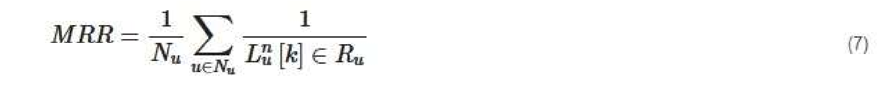 where *u*, *Nu* and *Ru* indicate specific user, total number of users and the set of items rated by the user, respectively. *L* indicates list of ranking length (*n*) for user (*u*) and *k* represents the position of the item found in the he lists *L*.

*MAP:* MAP is calculated by determining the mean of average precision at the points where relevant products or items are found. MAP as mentioned by [[65]](https://encyclopedia.pub/entry/13081#ref_65) can be expressed as follows.

 where Pu represents precision in selecting relevant item for the user. NDCG: NDCG is calculated by determining the graded relevance and positional information of the recommended items, which can be expressed as follows [[65].](https://encyclopedia.pub/entry/13081#ref_65)

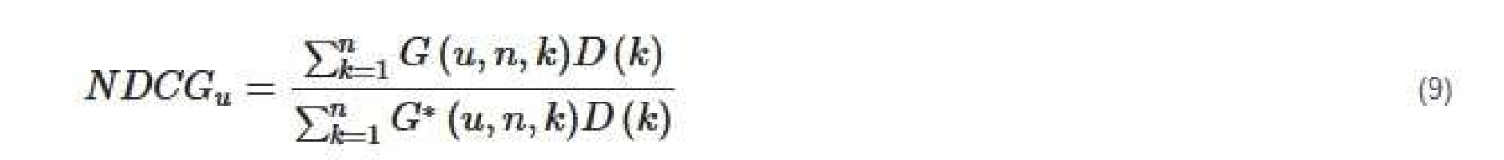 where *D* (*k*) is a discounting function, *G* (*u*, *n*, *k*) is the gain obtained recommending an item found at *k*-th position from the list L and *G*\* (*u*, *n*, *k*) is the gain related to *k*-th item in the ideal ranking of *n* size for u user.

**10.ADVANTAGES & DISADVANTAGES**

**ADVANTAGES:**

* Smart fashion recommender application is the user friendly.
* With the help of chatbot user cand find the products very easily.
* This application used to discover the product based on the user’s choice , very easily and quickly.
* It have ability to reduce transaction costs for consumers,and increase revenue for

retailers.

**DISADVANTAGES:**

* It need active internet connection.
* Privacy concerns.
* Too many choices.
* Cold-start problem.

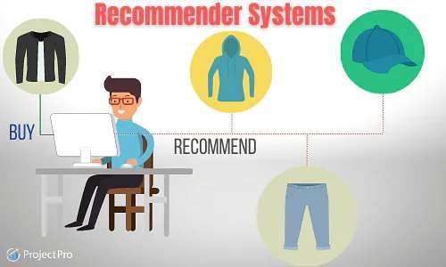

**11. CONCLUSION**

The Fashion Recommendation System is mainly used to recommend the best possible outfit combinations to a user who has no fashion sense based on their wardrobe . It may not always provide the best possible outfit to wear for an occasion as the system is dependent completely on the clothes present in the user’s wardrobe. Also another reason is that fashion is highly dependent on the time period. However the system does a great job in inculcating a fashion sense among the users and can provide the best recommendations based on the user’s wardrobe. Since the system is implemented as a website, it is very easy for the end users to access as well as use. The scope of this system can be expanded by including the ability to detect the various design and patterns on clothing, and to increase the number of occasions.

Recommendation systems have the potential to explore new opportunities for retailers by enabling them to provide customized recommendations to consumers based on information retrieved from the Internet. They help consumers to instantly find the products and services that closely match with their choices.

## 12. FUTURE SCOPE

In the future, to implement this recommendation system to be extended to include male and non-binary fashion items including apparel, footwear, accessories etc. This work can further be enhanced to predict fashion items based on the skin colour and weather conditions.

Future research should concentrate on including time series analysis and accurate categorization of product images based on the variation in colour, trend and clothing style in order to develop an effective recommendation system. The proposed model will follow brandspecific personalization campaigns and hence it will ensure highly curated and tailored. offerings for users. Hence, this research will be highly beneficial for researchers interested in using augmented and virtual reality features to develop recommendation systems.

For different markets, it could split in short-term and long-term recommendations in the future research. Current discussions and reviews are all based on short-term recommendations toward apparel retailing markets. It delivers real-time recommendations straight to the online shoppers as shopping advice and suggestions. Apart from online shopping, recommendations could also be utilized in design and manufacture by providing long term recommendations, such as predicting new trends through years and seasons.

|  |
| --- |
| PNT2022TMID02807        **13.APPENDIX**  **SOURCE CODE:**    **HOMEPAGE.html:**  <style> body { background: #2a2e32;  }    .text-small { font-size: 0.9rem;  } a { color: inherit; text-decoration: none; transition: all 0.3s;  } a:hover, a:focus { text-decoration: none;  }    .form-control { background: #212529; border-color: #545454;  }    .form-control:focus { background: #212529;  } footer {  background: #212529;  }    /*=============    ==================*/  /* ==========================================        47 |

|  |
| --- |
| PNT2022TMID02807      Rating stars  ========================================== */  .checked { color: orange;  }  </style>      <div style="background-color: rgba(0, 11, 86, 0.874);">  <marquee direction="left" style="color: white;font-size: larger;backgroundcolor: black;">Deals & special offer upto  20% wekend special sales upto 40% (Fashion sale for all products 50% offer shop now) </marquee>    <nav class="navbar navbar-expand-lg navbar-light bg-light" style="paddingbottom: 20px;padding-left: 150px;">  <a class="navbar-brand" href="{% url 'home'%}" style="margin-left:  500px;font-weight: 900;">  <img src="{% static 'image/smart.png'%}" width="250" height="200" alt="">  <p style="font-family: 'Times New Roman', Times, serif;"><i class="fa fa-map-marker" aria-hidden="true"> Smart  Fashion, 44, Townhall Road, Coimbatore-641039</i></p>  </a>  <br>    <button class="navbar-toggler" type="button" data-toggle="collapse" datatarget="#navbarNavAltMarkup" aria-controls="navbarNavAltMarkup" aria-expanded="false" arialabel="Toggle navigation">  <span class="navbar-toggler-icon"></span>  </button>    </nav>  <nav class="navbar navbar-expand-lg navbar-light bg-light">  <div class="collapse navbar-collapse" id="navbarNavAltMarkup"  style="background-color: rgba(8, 7, 7, 0.923);padding-top: 20px;paddingbottom: 20px;border-radius: 20px;"> <br>        48 |

|  |  |  |
| --- | --- | --- |
| PNT2022TMID02807         |  | | --- | | <div class="navbar-nav">  <a href="{% url 'home'%}"><button class="btn btn-outline-success" style="color: white;margin-left: 100px;font-size: larger;borderradius: 20px;">Home</button></a>  <a href="{% url 'about'%}"><button class="btn btn-outline-success" style="margin-left: 00px;color: white;margin-left: 80px;font-size:  larger;border-radius: 20px;">About Online  Smart  Fashion </button></a> |         **CHATBOT (SOURCE CODE) :**   |  | | --- | | function talk(){ var know = {  "Hi" : "Hello ",  "What say about your smart fashion?" : "This shopping hall is 2011 is start in smart fashion shopping and all vertical dress available.",  "What about your dress collection?" : "Court and shirts, Sarees, Jean  Pants, Kid's Dress, ect...",  "How to Purchasing?" : "Your see the top navbar, click on purchase button then you have purchasing dresses.",  "Your followers" : "I have my family of 5000 members, i don't have follower ,have supportive Famiy ", "ok" : "Thank You So Much ",  "Bye" : "Okay! Will meet soon.."  }; var user = document.getElementById('userBox').value; document.getElementById('chatLog').innerHTML = user + "<br>"; if (user in know) {  document.getElementById('chatLog').innerHTML = know[user] + "<br>";  }else{ document.getElementById('chatLog').innerHTML = "Sorry,I didn't understand  <br>";  }  } |             49 |

|  |
| --- |
| PNT2022TMID02807        **GITHUB & PROJECT DEMO LINK**    **GITHUB LINK:**  https://github.com/IBM-EPBL/IBM-Project-17720-1659675515        50 |